Comprehensive Assignment 08
Evidence
CREATE DATABASE IF NOT EXISTS minha_sdet;
USE minha_sdet;
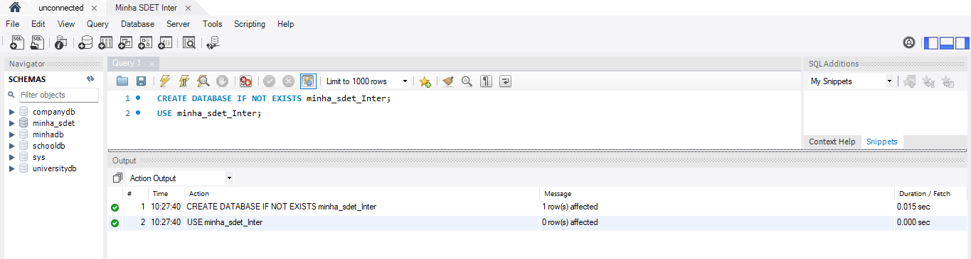
CREATE TABLE EMP_Data (
EMP_No INT PRIMARY KEY,
EMP_Name VARCHAR(100),
EMP_Exp INT,
EMP_Department VARCHAR(50),
EMP_Salary INT
);
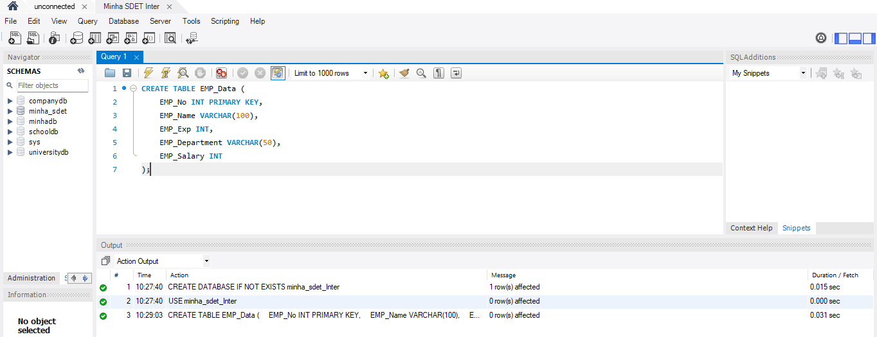
INSERT INTO EMP_Data (EMP_No, EMP_Name, EMP_Exp, EMP_Department, EMP_Salary)
VALUES
(101, 'John Smith', 5, 'IT', 60000),
(102, 'Alice Johnson', 3, 'HR', 45000),
(103, 'Bob Williams', 7, 'IT', 75000),
(104, 'Catherine Brown', 2, 'Finance', 40000),
(105, 'David Miller', 4, 'HR', 50000),
(106, 'Emma Davis', 6, 'Finance', 70000),
(107, 'Frank Wilson', 8, 'IT', 90000);
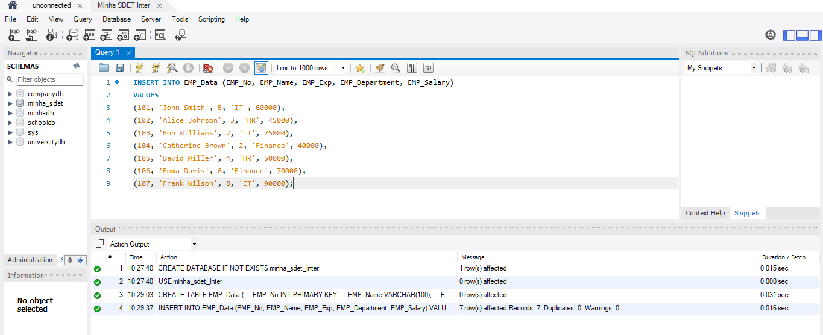
SELECT * FROM EMP_Data;
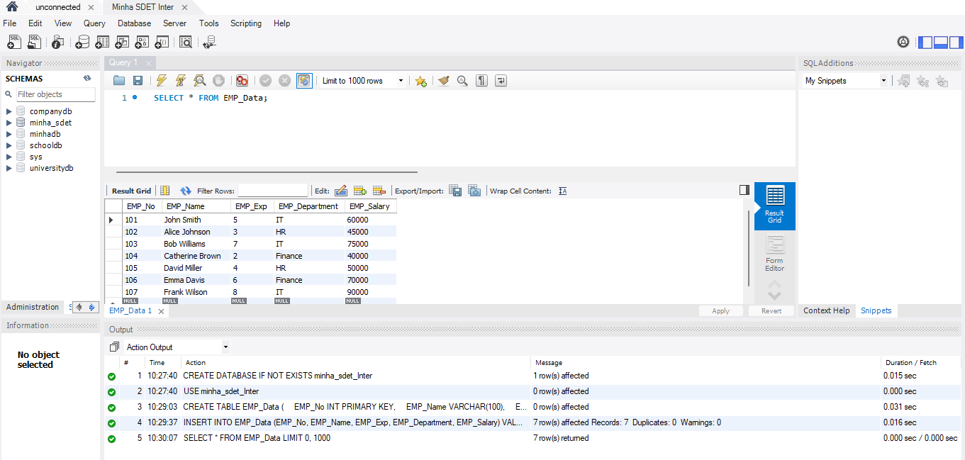
SELECT *
FROM EMP_Data
WHERE EMP_Department IN (
SELECT EMP_Department
FROM EMP_Data
GROUP BY EMP_Department
HAVING COUNT(*) > 1
)
ORDER BY EMP_Department, EMP_No;
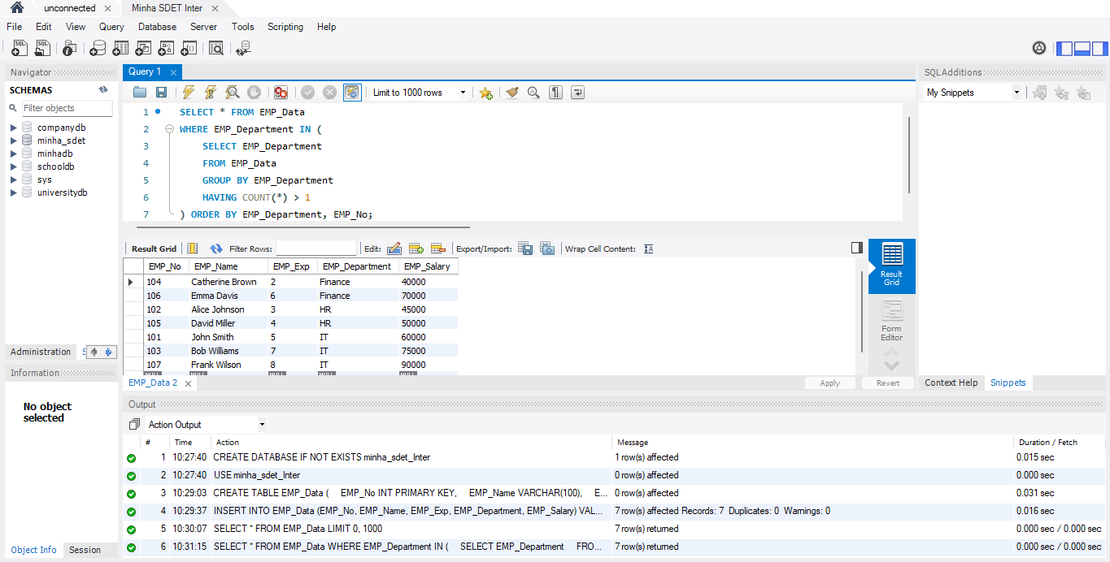
SELECT DISTINCT e1.*
FROM EMP_Data e1
JOIN EMP_Data e2
ON e1.EMP_Department = e2.EMP_Department
AND e1.EMP_No <> e2.EMP_No
ORDER BY e1.EMP_Department, e1.EMP_No;
